**GEELONG SPORTS AVIATORS**

**DECEMBER 2022 NEWSLETTER**

Dear Members.

Weather conditions have certainly had an impact on us in 2022. Hopefully none of you were affected by the severe flooding events that have devastated so many Australian towns. From a flying perspective the weather has significantly reduced our chances of flying away. We can only hope that the weather will take a turn for the better in 2023 and we can spend more time doing the thing we all love to do.

This will be the last Newsletter for 2022. I have been a member of the Geelong Sports Aviators since 2002 and 2022 was my first time as secretary, taking over from Tony Miller. I thought after all that time it was about time I took on a committee position and I hope I have done at least half as good a job as Tony did. He left some big shoes to fill. I’m looking forward to continuing the role in 2023 however in the meantime I wish you all a very Merry Christmas and a Happy New Year.

**PRESIDENT’S MESSAGE:**

Hi to all and hope you’re excited for the upcoming Xmas breakup at Ocean Grove Bowls club on Saturday night.

As you may have already noticed, the Gazelle is on-line again and there are already members taking to the skies.

Finally, another CASA night is planned for Feb 16, 2023 at the Lethbridge so please register your attendance via the link below,

Fly safe and enjoy,

Bill Dickers

President

Geelong Sports Aviators

**CASA SAFETY SEMINAR**

CASA will be conducting a free safety Seminar on February the 16th at the Lethbridge Air Park commencing 6:30pm. If you wish to attend CASA has requested you register your interest prior to the event by one of the online options below. Just press ctrl and click on either of the underlined links. Registration is easy, so easy in fact I accidently registered myself twice. Having attended one before I can highly recommend it.

CASA uses an online registration tool to track attendance at the seminars. Your assistance in encouraging attendees to register online is appreciated and essential.

The registration process is easy –  [Click here](https://www.eventbrite.com.au/e/avsafety-seminar-lethbridge-tickets-482718071747) to register now or log onto [www.casa.gov.au/events](http://www.casa.gov.au/events) , find the seminar and click to register.

The AvSafety Seminars are free to participants.

**AIRPORT NEWS:**

**North/South runways**

The North/South runway maybe be open again very soon, possibly on the weekend. Gary will be inspecting it at time of writing and will make a decision, but he says if we don’t get any more rain it will possibly be open by the weekend.

**Commercial Operations**

A crop duster is currently operating from the airfield. He will give everyone flying in and out of the airfield right of way so if you make the usual radio calls he will stay out of your way.

2 PC-12’s will be flying in and out of the airfield at various times conveying passengers to and from various locations, see attached pic.

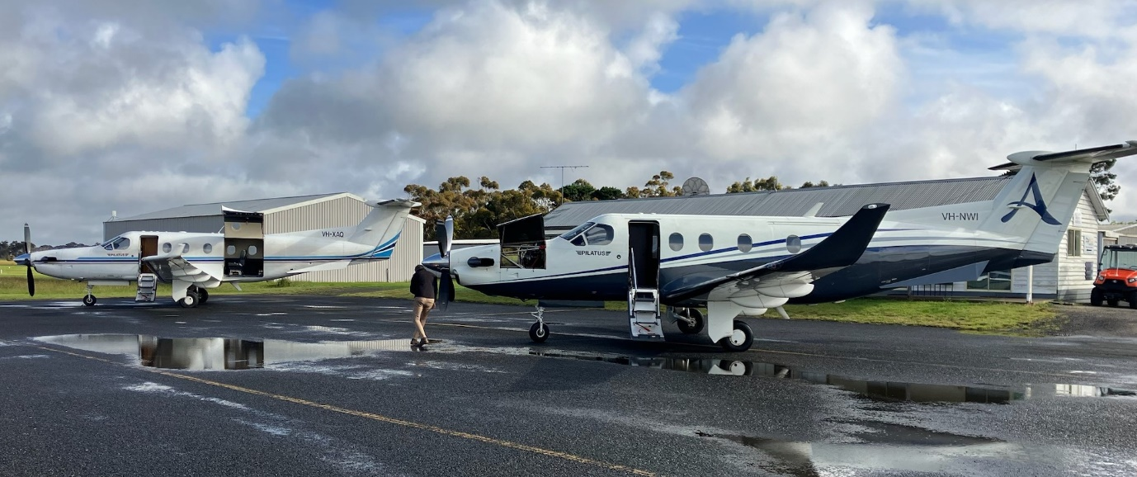

**Hangar Warming**

Steve Cooper, otherwise known as the cray fish guy, put on a magnificent hangar warming party for anyone who was lucky enough to be at the airfield on the day. It was a magnificent event with plenty of food and live music. If you don’t know Steve he is the guy who brings in live cray fish and scallops for sale so if you are looking for some fresh sea food for Christmas he is the guy to contact.

**Hangar News**

There is one hangar left to be concreted and once that is complete Gary will be contacting the shire in preparation for having a new row of 9 hangar blocks for sale. Judging from past history these will sell very quickly so if you are looking for a good investment, as a hangar owner myself, I can highly recommend getting on board.

There are some hangar spaces available for anyone requiring them. Please contact Gary via the Lethbridge Air Park Website or contact him directly if you require some space in a hangar.

**NEW MEMBERS:**

We would all like to welcome Norm Hite to our group of enthusiastic aviators. Norm will have his aircraft hangered at Robbie Wiffen’s property and flying into Lethbridge when he can so welcome Norm.

**FLYAWAYS:**

**DECEMBER** – Day trip to the Birchip, 128nm approx. 1.5hrs, visiting Sharps Bakery for coffee and their award-winning vanilla slices. The plan is to leave Lethbridge just after 9:30am and my wife will be waiting at the other end to ferry us into town. Please let me know if you wish to attend so I can contact the bakery and have some vanilla slices put away for us. So far 4 plane owners have expressed their intentions of attending and there is one spare seat available for anyone wanting to come along.

**JANUARY** – Overnight trip to Devonport or Barren Island. Destination to be confirmed as we get closer to the time. President Bill Dickers will be organising that trip.

**FEBRUARY –** Most of us will be flying our plans into Avalon Airport for the air show but there is still plenty of time to organise a flyaway beforehand if anyone is interested. If anyone has any ideas please let me know and we can organise something.

**CHRISTMAS PARTY**

Our Christmas party this year is going to be held at the Ocean Grove Bowls club this Saturday the 10th December commencing 6pm. The cost is $45 per head for a 3 course meal, drinks to be purchased at the bar. Either Bill or David will collect the money from everyone prior to entering the bowls club. There will be a bus leaving Lethbridge Airpark at 5pm and picking up people at Batesford and Mt Duneed. It will leave the bowls club at 10pm for the return trip and it will be free of charge. A big thanks to David Maruskanic for organising this years Christmas party and im looking forward to seeing you all there.

**CLUB PLANE:**

As our president stated in his message, the club plane is up and running and being utilized by some of our members. Should you wish to hire it just go to the Geelong Sports Aviators website and you will find booking details and hire cost available there.

**FOR SALE:**

Should you wish to sell any aviation-based items please send me the details and any pics and I will add it here.

Jabiru SP500. $30,000 ono

Contact Peter 0407 841 616 for more information and a test flight.

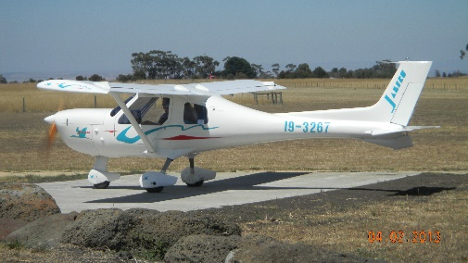

Peter Newell

Secretary GSA

Phone: 0407 841 616

Email: [pnewell58@bigpond.com](mailto:pnewell58@bigpond.com)

**GEELONG SPORTS AVIATORS COMMITTEE**

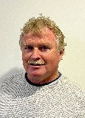 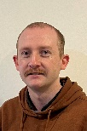 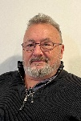 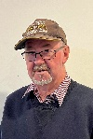 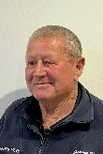 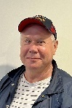 

**President** **Treasurer** **Secretary**  **Committee** **Committee** **Committee**  **Committee**

Bill Russell Peter Andrew Robbie David Mark

Dickers Oliver Newell Westland Wiffen Maruskanic Wiffen

GSA QR code - (Use QR code as a link to our website)